**Purpose:** To recreate the topology that was created in class, and to familiarize ourselves with basic Cisco IOS.

**Topology**

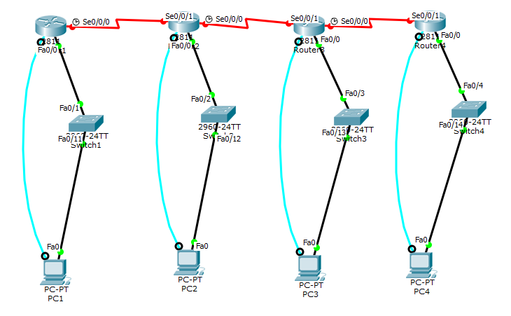

**Command Syntax**

|  |  |
| --- | --- |
| *Enable* | Elevates user to privileged executive mode 1-15 (set by user) |
| *Enable Password* | Sets a password, combined with *login* to create a login system for the router |
| *Login* | Enables “login” feature the next time someone tries to connect to the router |
| *Exit* | Leave the interface you are currently in |
| *Conf T* | Short for “Configure Terminal”, Allows configuration of router |
| *Logging Synchronous* | Disables logging to the console |
| *Telnet* | Protocol to remotely access a device (unsecure) |
| *Line VTY* | Allows access to the Virtual Terminal Line Configuration |
| *Line Console 0* | Allows access to line configuration mode |
| *Show Interface* | Shows all interfaces on the router |
| *Show IP Interface Brief* | Shows network connections, with their names shorten as possible, but still allowing for comprehension. |
| *Show Ip Route* | Displays the current routing table for the selected router. |
| *IP Address* | Sets the IP Address for the selected device. |
| *No Shutdown* | Disables the ability for the device to be disconnected from the network |

**Verification**

PC1 – Route1

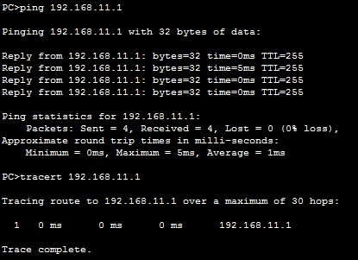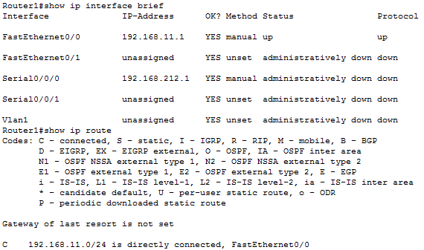

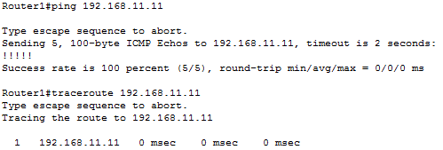

PC2 – Router2

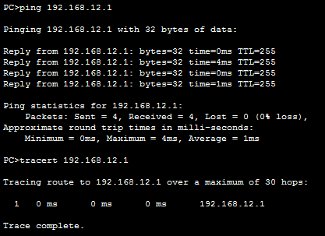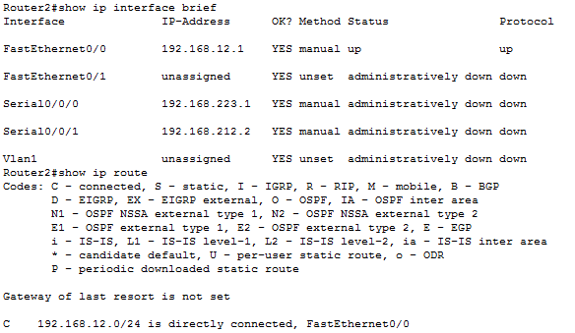

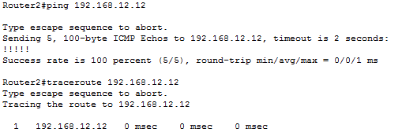

PC3 – Router3

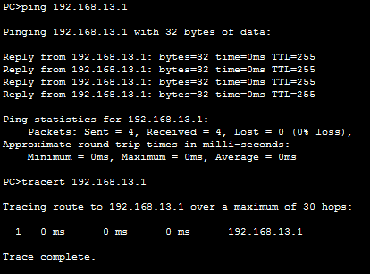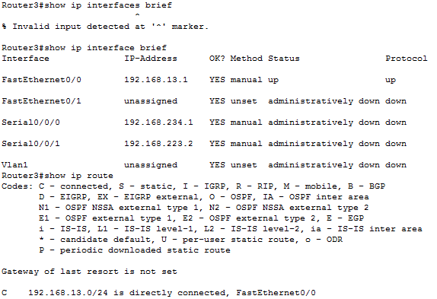

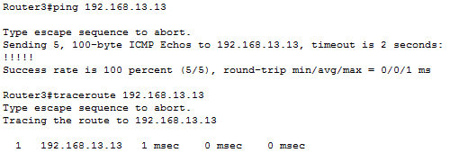

PC4 – Router4

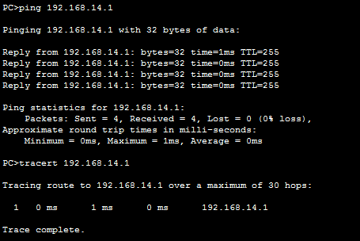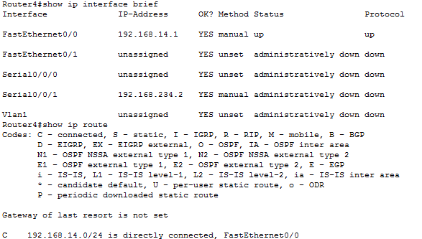

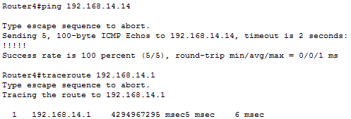

**Results/Outcomes**

The hardest part of this lab was trying to remember all the steps that we covered in class. Learning and memorizing the Cisco commands was also challenging but goes to prove that the “?” really is your best friend in Internetworking. In the end I was able to ping to and from the PC to the Router, which I consider to be a success.